Racetrack Infractions and Incidents

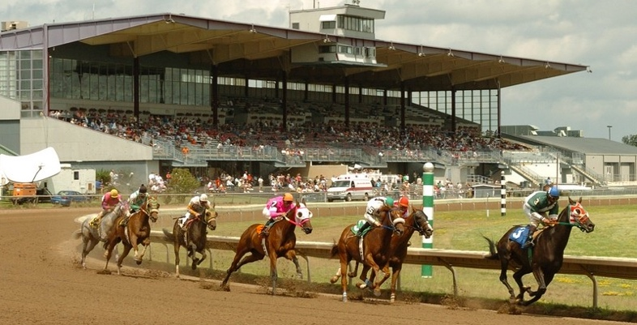

Analysis of New York State Racetrack Rulings and Incidents   
between 2009 and 2019

Joyce Woznica  
IST 652  
  
Date: June 5, 2020

Table of Contents

Introduction 4

Data 4

Rulings (Infractions) Data 4

Incident Data 5

Twitter Accounts/Hashtags 5

Overall Data Approach and Pre-Processing 6

Program Description 6

Analysis 6

Overall Infractions 7

Infractions by Race Track 7

Infractions by Race Type 7

Infractions by Individual 8

Infractions by Occupations 9

Infractions over Years by Track 9

Infractions over Month/Year by Track 10

Common Infraction Words 11

Ruling Types 13

Total Count of Rulings by Type 13

Suspensions 14

Total Count of Suspension Days by Number of Days 14

Overall Fines 15

Total Fines by Individual by Occupation 15

Average Fine by Occupation 17

What are People Saying about the Tracks 18

Latest Comments About New York State Horse Racing 18

Relationship Between Infractions and Incidents 19

Incidents by Date, Track and Type with Overlapping Infractions 19

Total Incidents by Type with Overlapping Infractions 20

Infractions and Incident Overlaps 20

Conclusion 21

List of Figures

Figure 1. Infractions by Race Track 7

Figure 2. Infractions by Race Type: Harness or Thoroughbred 8

Figure 3. Infractions by Individual 8

Figure 4. Infractions by Occupation 9

Figure 5. Infractions by Fine Year by Race Track 10

Figure 6. Race Tracks with Highest Number of Infractions by Year/Month 10

Figure 7. Initial Word Cloud of Commonly Appearing Words 11

Figure 8. Final Word Cloud of Commonly Appearing Words 12

Figure 9. Top 12 Words in Infraction Descriptions 13

Figure 10. Ruling Types by Count 14

Figure 11. Most Common Length of Suspensions 15

Figure 12. Total Fines by Individual 16

Figure 13. Refined Total Fines by Individual 16

Figure 14. Average Fine by Occupation 17

Figure 15. Refined Average Fine by Occupation 17

Figure 16. Word Cloud of Commonly Appearing Words 18

Figure 17. Word Cloud of Commonly Appearing Words from @racingwrongs 19

Figure 18. Incidents by Track, Type and Date 20

Figure 19. Incident Types from Merged Data 20

Figure 20. Infractions and Incidents with Same Individuals Involved 21

# Introduction

Each race conducted at a New York Thoroughbred racetrack is observed by three stewards: one employed by the Racing and Wagering Board, one employed by the racing association and one employed by the Jockey Club. At the harness tracks, each race is observed by three judges who all serve as employees of the Racing and Wagering Board. The stewards’ and judges’ viewing stand is located near the finish line of each racetrack and is equipped with several television monitors to permit the viewing of multiple angles of each race. The stewards and judges observe the races and the race grounds to ensure that all conduct is in accordance with rules and regulations.

The hopes are that with citing individuals breaking the rules will help mitigate risk as well as encourage compliance with rules in the future. Since the horse racing industry is plagued with accidents resulting in equine injury, rules exist to attempt to minimize these incidents and to protect the riders, drivers and of course, the horses. Further investigation can shed light on contributing factors and provide insight into what leads to the high number of infractions. Armed with this information, tracks can put the proper constraints in place in the future to minimize infractions that could also minimize incidents.

# Data

To begin such an investigation, a subset of both harness and thoroughbred racetracks within New York State (NYS) has been studied. Although three datasets are available, the following two were selected for this analysis. In addition, Twitter accounts and hashtags were used and are documented as data in this section.

## Rulings (Infractions) Data

There are few racing jurisdictions that have equaled New York’s strong stand on integrity in horse racing. Over the past decade, the Board has enabled more capable and qualified people to become stewards and presiding judges at racing events. Rulings are captured and detailed in this data set.

|  |  |  |
| --- | --- | --- |
| Data Label | Data Type | Data Description |
| Fine Year | Numeric | Year of ruling |
| Notice | Text | Notice ID number |
| Full Name | Text | Licensee’s full name |
| Race Track | Text | Issuing location |
| Race Type | Text | Racing division: Harness or Thoroughbred; “?” indicates unknown |
| Type | Text | Type of ruling: Fine, Suspension, Denial |
| Notice Date | Date | Date of Notice for ruling |
| Rules | Text | Rules violated; public reference list of rules available at http://www.gaming.ny.gov/statutes.php |
| Ruling Text | Text | Text description of the ruling |
| Occupation | Text | Licensee’s occupation |
| Fine Amount | Numeric | Fine amount in dollars |
| Suspension Start Date | Date | Suspension starting date |
| Suspension End Date | Date | Suspension ending date |
| Days Suspended | Text | Number of days suspended or description of period of suspension |

This data was obtained from the New York State government website: <https://data.ny.gov/Government-Finance/Horse-Racing-Rulings-Beginning-1985/igam-2tkj>

This data is called *horse-racing-rulings-beginning-1985.*csv and contains rulings since 1985. This set has 36,790 rows and 14 columns. For this analysis, only the years from 2009 through 2019 were used.

## Incident Data

Within the state of New York, any incident, death or breakdown of any horse at any facility under the Gaming Commissions’ jurisdiction is reported. Once the data is verified, it is entered into a database that contains thirteen components that detail over four thousand incidents at New York State equine racetracks starting in 2009 to present day. For this analysis, data from 2009 through 2019 was used.

|  |  |  |
| --- | --- | --- |
| Data Label | Data Type | Data Description |
| Year | Numeric | Year of Incident |
| Incident Date | Date | Date of Incident |
| Incident Type | Text | Type of Incident: Death, Breakdown, Injury, etc. |
| Track | Text | Location of Incident |
| Inv Location | Text | Location on Track |
| Division | Text | Racing division: Harness or Thoroughbred |
| Weather Condition | Text | Weather conditions at time of incident |
| Horse Name | Text | Horse name |
| Trainer | Text | Trainer’s Name |
| Jockey Driver | Text | Jockey or Driver’s Name |
| Incident Description | Text | Text of incident |
| Death or Injury | Text | Death or Injury |

Source: <https://data.ny.gov/Government-Finance/Equine-Death-and-Breakdown/q6ts-kwhk>

## Twitter Accounts/Hashtags

To gather additional information about how the race industry is seen from the eyes of observers as well as what it made public about certain infractions or incidents, the following twitter accounts and hashtags were reviewed.

|  |  |
| --- | --- |
| Race Track | Associated Accounts and Hashtags |
| Aqueduct Racetrack | #aqueductracetrack |
| Batavia Downs | @BDRacetrack, #bataviadowns |
| Belmont Park | #belmontpark, @BelmontStakes |
| Buffalo Raceway | @BuffaloRaceway, #buffaloraceway |
| Finger Lakes Gaming & Racetrack | @FLGaming, #fingerlakesracetrack |
| Monticello Raceway & Mighty M Gaming | #monticelloraceway |
| Saratoga Gaming & Raceway | @SaratogaNYRA, #saratogarraceway |
| Tioga Downs | @gotiogadowns, #tiogadowns |
| Vernon Downs | @governondowns, #vernondowns |
| Yonkers Raceway | @YonkersRaceway, #yonkersraceway |
| All Tracks | @racingwrongs, @HR_Nation, @TheNYRA, @NYSGamingComm, @NYRABets |
| Harness Tracks | @trotinsider, #harnessracing |
| Thoroughbred Tracks | @SireStakesNY, @Equibase |

## Overall Data Approach and Pre-Processing

A subset of the data was used for this analysis reducing the data to the last decade (2009 – 2019). This reduced the primary dataset of rulings to 11,516 rows and 14 columns. No other data was initially removed except a single row with a *NaN* value for the “Notice Date”. Other data was not removed because when evaluated, the missing data was either not required and would not affect the final results. However, in the response to some questions, some data was removed for graphing purposes or to better respond to the question.

All data was read into a *pandas* dataframe for manipulation. Outputs with summarized or gathered information from the source data was also placed into a dataframe before plotting with *seaborn* and other graphic packages as appropriate.

# Program Description

The code is well commented; however, the program is outlined in the following sections:

* Package Import  
  In this section, the packages that will be used as part of the program are imported.
* Data Load and Manipulation  
  In this section, the data is loaded by reading the *csv* file into a *pandas* dataframe for manipulation. A full path name was provided to the datafile for reading. As mentioned, earlier years were removed from the data so the data only reflects the last decade. Missing data was investigated.
* Analysis and Graphing – Structured Data  
  The next sections in the program consists of manipulating the data into different subsets to answer specific questions and for visualization purposes. The *seaborn* package was used for graphing. This section includes a set of analysis and graphs done on structured data.
* Analysis and Graphing - Unstructured Data

Unstructured data within the rulings dataset was read and then stored in a dataframe for further manipulation and graphing purposes. Twitter data was read and stored in MongoDB and then the collection was searched and read into dataframes from manipulation and graphing.

* Merged Data Set Analysis and Graphing

The two data sets were merged by Year, Date, Track and Racetrack Division (Harness or Thoroughbred). This data was reviewed to gather information about the relationship between infractions and incidents on the tracks.

**Note: Twitter Data was captured and graphed on June 3, 2020.

# Analysis

As part of reviewing this data set, the following questions were analyzed and explored to have a better understanding of infractions on New York State horse racing tracks over the last decade. These have been broken into the following groupings:

* Overall Infractions
* Ruling Types
* Suspensions
* Overall Fines
* What People are Saying about the Tracks
* Relationship between Infractions and Incidents

## Overall Infractions

The first set of questions were related to summing the number of infractions and grouping them in different ways to look for trends or other information that gave us some additional insight into the data.

### Infractions by Race Track

Which tracks have the most infractions?

In order to review which tracks have had the most infractions, the rulings data set is grouped by “Race Track” and then the number of matching infractions for each track is counted to provide a new smaller dataframe with just the data needed. For this visualization, we were not interested in any infractions with tracks noted as:

* Main Office
* New York Racing Association
* None

Only infractions specified as occurring at an individual racetrack were reviewed and data without a specific track name was removed. The final visualization is reflected in the following figure.

Figure Infractions by Race Track

As reflected in the graph, three (3) racetracks showed a significantly higher number of rule infractions: Yonkers Raceway – with almost 1,400, Saratoga Gaming & Raceway and Monticello Raceway & Mighty M Gaming – with both just under 1,200 infractions. These are all Harness Racing tracks. These results led me to the next question.

### Infractions by Race Type

Are there more infractions in Harness or Thoroughbred Racing?

Since the three tracks that had a significantly higher number of infractions that the others were all Harness Racing tracks, I took a look at Harness Racing versus Thoroughbred Racing to confirm that Harness Racing has more overall infractions. The same coding was applied to create a subset of data specific to the number of infractions by Race Type. However, there was extraneous information (Race Type = “?”) which was removed prior to graphing. The results are in the following figure.

Figure Infractions by Race Type: Harness or Thoroughbred

### Infractions by Individual

Are certain individuals receiving higher numbers of infractions that others?

Continuing with this approach, I wanted to gather information about individuals to see if any had a higher number of infractions than others. Because of the sheer number of individuals, a subset of the top 25 individuals with the highest number of infractions was taken. Clearly, there are two individuals: Jason J. Bartlett and Kevin J. Cummings with a much higher number of infractions with over 100 each. The resulting graphic is shown below.

Figure Infractions by Individual

Since individuals often have different roles or occupations, this led me to another question about which actual occupations (groom, jockey, trainer, owner, driver, etc.) receives the most infractions over the decade chosen.

### Infractions by Occupations

What occupation has the most infractions?

As mentioned, many individuals in the industry have multiple roles or occupations in the horse industry. For example, some owners are also trainers or drivers. Some jockeys are also exercise riders. As a result, there are 95 different occupations listed in the rulings information for various individuals in the data set. These occupations might be something like “Driver” or “Trainer” or “Jockey” or a combined role of “Owner-Trainer-Driver” or “Owner-Trainer”. No specific deeper dive was approached around occupations, but the top 25 occupations showing the most infractions was graphed with the results on the following page.

Figure Infractions by Occupation

Based on this information, it was clear the most citations are given to owners, trainers, drivers and jockeys. I was slightly surprised that grooms were on this list, but when I can take a closer look at the individual citation types, this may be drug related as drugging a horse before a race is strictly prohibited.

### Infractions over Years by Track

What are the number infractions over the years by track?

To review possible trends in the data, I wanted to take a look at the infractions by track over the decade. This can help determine if certain tracks are seeing more rule violations and if there are certain years when violations were at an all-time high.

This was accomplished by creating cross tables of the data for the “Fine Year” and the “Race Track” and visualizing this information over a time series plot by racetrack as shown in the following figure.

Figure Infractions by Fine Year by Race Track

As part of the further analysis of this data, it is clear that infractions took a leap in 2018 at the same three tracks seen when we looked at the tracks with the most infractions overall. It is also interesting to note that Tioga Downs, another Harness track, has low infractions. However, this may be do less race starts at this location. We can also see that Thoroughbred tracks have a lower number of infractions overall.

### Infractions over Month/Year by Track

What tracks show the highest number of infractions in a single month/year?

Since racing is not year round in the state of New York, certain months may have a higher number of violations than others. To determine this, the data was manipulated to extract the month from the “Notice Date” for each infraction. This was then grouped by “Fine Year”, “Month” and “Race Track” and consolidated into a small dataframe with just the tracks during a certain month and year that infractions were over 28 in that month. This result can be seen in the following figure.

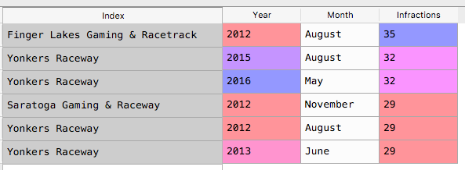

Figure Race Tracks with Highest Number of Infractions by Year/Month

The first thing I noticed was that only three (3) tracks appear and two are harness track:

* Yonkers Raceway – Harness Racing
* Finger Lakes Gaming & Racetrack – Thoroughbred Racing
* Saratoga Gaming and Raceway – Harness Racing

In addition, Yonkers Raceway appears in four (4) times in the top six (6) tracks. This is the same track that has had an increase over the last decade in noted violations.

### Common Infraction Words

Are their common threads or words in the descriptions of the infraction?

As part of the information gathered for an infraction is an explanation of the circumstances behind the notification with some free form text. This could shed some light on if the violation was related to inappropriate behavior on the track or ill treatment of the horse, etc. This ruling text was extracted for all infractions across all racetracks to take a deeper look at this information.

#### First Pass of Top Infraction Words

The first attempt at reviewing this words within the ruling text was done with only a few standard “stop” words removed in addition to things like New York. That list is shown here:

﻿stopwords = set(STOPWORDS)

stopwords.update(["is", "of", "nbsp", "for", "the", "a", "he", "you", "to",

"in", "with", "are", "new", "york", "state", "will", "hereby",

"quot", "may"])

After the removal of these words, the resulting top 175 words were visualized using a word cloud. In this word cloud, the most common words (or the words that appear most often in the ruling text) are depicted in larger font.

Figure Initial Word Cloud of Commonly Appearing Words

It was clear that many of these were related to the gaming side or notes made about the actual action taken (suspension or fined, for example). To take a deeper look, I took another pass as noted in the next section.

#### Fine Tuned Word Cloud

After careful review of this representation and some intermediate visualizations increasing the number of stop words to fine tune the final word cloud, additional words were removed as follows:

﻿stopwords.update(["is", "of", "nbsp", "for", "the", "a", "he", "you", "to",

"in", "with", "are", "new", "york", "state", "will", "hereby",

"quot", "may", "race", "racing", "pari-mutuel",

"driving", "license", "participate", "fined", "hereby", "suspension",

"licensing", "failed", "horse", "requirements", "notified", "commission",

"racetrack", "receipt", "board", "comply", "day", "consideration",

"gaming", "wagering", "purse", "quot", "1st", "2nd", "3rd", "4th", "5th",

"6th", "7th", "8th", "9th", "invoice", "january", "february", "march", "april",

"may", "june", "july", "august", "september", "october", "november", "december",

"suspended", "days", "violation", "pari", "mutuel", "reason", "respondent",

"nycrr", "hearing", "appeal", "rule", "employee", "fine", "rules", "general",

"right", "employ", "sunday", "monday", "tuesday", "wednesday", "thursday",

"friday", "saturday", "sunday", "generally", "mr", "person",

"downs", "statement", "calendar"])

This final tuned word cloud is represented in the following figure.

Figure Final Word Cloud of Commonly Appearing Words

Unfortunately, little insight could be gained from this information, but you will see some important words like “trainer”, “driver”, and “owner” and less of “jockey” which implies that these individuals appear more in the infractions. You will also see some words that indicate the rule breaking:

* ground
* refuse
* paddock
* raceway
* interference
* indirectly
* following
* stretch
* inside
* fitness
* failure
* drive
* drug

Knowing something about the types of rules that can be broken and the race industry, many of these words lead us to believe that interference during a race, or someone was following too closely to another cart/horse, possibly something happening in the stretch or even an illegal equine drug could have led to the infraction. You can see “yonkers” in the words as well – which is used in the next question asked of the data.

Finally, the top 12 words (after stop words were removed) were used to create a pie charts of the details, unfortunately, little could be gained from this visualization.

Figure Top 12 Words in Infraction Descriptions

## Ruling Types

The next set of questions were around the types of rulings (Fine, Suspension, etc.) and how they are distributed for the past decade.

### Total Count of Rulings by Type

What is the most common Ruling Type?

A a simple bar graph visualization of the ruling types over the last decade plotted by the number this ruling type occurred is shown in the following figure.

Figure Ruling Types by Count

It is clear, based on this information, that Fines are predominate for rulings over the last decade. However, suspensions have also occurred which I wanted to review a little closer.

## Suspensions

The suspensions given range from 0 days up to an entire year (365 days). Often times the severity of the violation is aligned with the suspension period.

### Total Count of Suspension Days by Number of Days

What is the most common length of a Suspension?

To help to determine what suspensions are given most often, the data was reviewed and then grouped by suspension period to show the count of each suspension period as reflected in the following figure.

Figure Most Common Length of Suspensions

It is abundantly clear that the standard suspension period is 3 days. However, 15, 30 and 60 days were also common. This is very interesting because in the United States Equestrian Federation, suspensions or things like drugging or ill treatment is at least 6 months and can me multiple years. This later federation governs the Olympic equestrian athletes and this may be why it is more strict.

## Overall Fines

The next set of questions were around the fines and how they are distributed over the individuals and occupations.

### Total Fines by Individual by Occupation

What is the highest fines paid by Individual by Occupation?

The first question was around the largest fines by individual and what role (occupation) that individual was performing on the track at the time of the citation. In order to simplify this plot, only those individuals with fines over $4,000 in a single occupation were used because of the sheer magnitude of individuals in the dataset. The first plot showing those individuals and occupations is in the following figure.

Figure Total Fines by Individual

The problem with this plot is that one individual, Luis Pena, in the occupation of trainer, has a significant number of fines and is therefore an outlier, close to $350,000 over the decade. The plot was redone by removing Mr. Pena from the dataset and that plot is shown in the following figure.

Figure Refined Total Fines by Individual

This representation provided a better slice of the data showing that Richard E. Dutrow Jr. has the highest fines in the occupation of Owner-Trainer, close to $50,000 over the last decade. Both of these visualizations indicate that trainers seem to have received the higher fines over time.

### Average Fine by Occupation

What is the average fine amount by occupation?

Finally, I looked at the average fine over the decade for each occupation. About 15 of the 95 occupations reported had fines reported as $0.00, those were removed. This could be due to the fact that the entry was a suspension or no fine was necessary. Then, to further subset the data, average fines under $50.00 were also eliminated.

Figure Average Fine by Occupation

As with the previous plot, there was an outlier, or a single occupation (Jockey Agent) with a much higher average fine, over $1,600. By removing this occupation and only showing average fines over $50.00, we see that Trainer/Exercise Riders, Racing Officials, Trainers and Owner-Trainers had the highest average fines over the decade from 2009 to 2019.

Figure Refined Average Fine by Occupation

## What are People Saying about the Tracks

### Latest Comments About New York State Horse Racing

I decided to see what people are saying about horse racing – both harness and thoroughbred racing through Twitter. I researched the tracks and racing entities to determine a set of accounts and hashtags to assist in gathering this information.

#### Current Racetrack Tweets

The following twitter accounts and hashtags were used to load the Mongo “racedb”. The top **375** most recent tweets for each item was returned.

* #aqueductracetrack, @BDRacetrack, #belmontpark, @BelmontStakes, @BufffaloRaceway, #buffaloraceway, @FLGaming, #fingerlakesracetrack, #monticelloraceway, @gotiogadowns, #tiogadowns, @governondowns, #vernondowns, @YonkersRaceway, #yonkersraceway, @racingwrongs, @HR_Nation, @TheNYRA, @NYSGamingComm, @NYRBets, @trotinsider, #harnessracing, @Equibase

In this case, all retweets were removed when the results were added to a dataframe for Word Cloud construction.

Figure Word Cloud of Commonly Appearing Words

Again, multiple iterations were done to remove words so that some conclusion or pattern could be seen. As reflected in the word cloud, these tweets provide little information except the search words we tried to find in the tweets and the various individuals that tweeted about them. I did try to remove the racetracks looking for anything further, but nothing really jumped out as a theme around the tweets with the exception that the tweets were very positive about the return of racing due to the delays around COVID-19 – words like “opening” and “return”. Some specific tracts were noted and one word did jump out to me which was “dead”.

#### Recent RacingWrongs Tweets

The following twitter account was used to load the Mongo “racewrongdb”. The top **1000** tweets were attempted with less than 300 returned.

* @racingwrongs

In this case, all retweets were removed when the results were added to a dataframe for Word Cloud construction.

Figure Word Cloud of Commonly Appearing Words from @racingwrongs

Again, multiple iterations were done to remove words so that some conclusion or pattern could be seen. Most of the work done was to remove individual account names (some still remain) to try to find some other meaning. This information was very clear as “@racingwrongs” tweets specifically about the dangers of horseracing. You can definitely see a theme with words like “euthanized”, “dead”, “cruel”, “killed”, “death” and “maimed” – indicating horses are experiencing a precarious future in the horse racing industry according to this individual.

## Relationship Between Infractions and Incidents

Because the two datasets existed over matching years, some research was done on if there was any relationship between infractions on a track on a specific day and if any incidents took place that day.

This involved merging the two datasets on multiple columns:

* Date
* Track
* Year
* Division – Harness or Thoroughbred

The resulting merge of matching information was a dataframe with only 59 rows. That means that there were only 59 occurrences where there was a violation at a track the same day that there was an incident at that track.

### Incidents by Date, Track and Type with Overlapping Infractions

What types of incidents occur the same day/track as an infraction?

To see if there was any trends that appeared, I did a visualization of the types of incidents that happened on the tracks on the same day that an violation happened on the same track.

Figure Incidents by Track, Type and Date

I was not surprised to see that “Racing Incident” was seen often as there are many rules around clipping another cart or bumping a horse on the track, etc. These would be categorized as racing incidents and usually there are fines associated with these incidents.

### Total Incidents by Type with Overlapping Infractions

What Incidents were most common on Overlapping Infraction days?

To see what types of incidents were most common in the merged data where there was an infraction the same day as an incident, I did a visualization on the 59 occurrences.

Figure Incident Types from Merged Data

As seen in the previous section, “Racing Incidents” were most common. Unfortunately, “Equine Death” was the second most common incident type.

### Infractions and Incident Overlaps

Where did infractions and incidents happen on the same track on the same day?

To take this a step further, it was important to see if the incidents and violations were related in any way. For example, was it the same jockey or trainer that was involved. The results of this investigation are shown in the simple print out generated showing the merged data in the following figure.

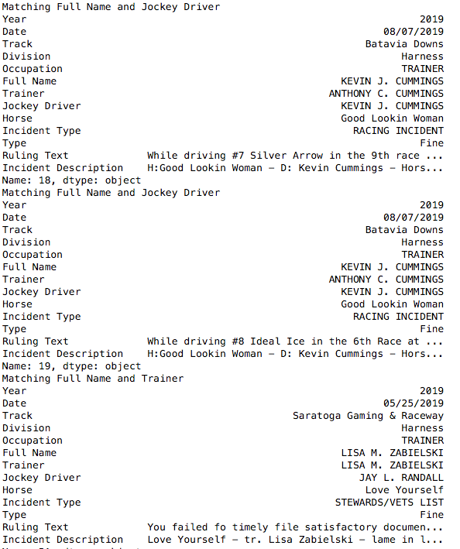

Figure Infractions and Incidents with Same Individuals Involved

As shown here, Kevin Cummings was the Driver on the same day at Batavia Downs when there was a Racing Incident. However, if you notice the text for the Incident and the Ruling – different horses were involved. The infraction was with a horse called Silver Arrow and again with a horse called Ideal Ice. However, the incident occurred with a horse called “Good Lookin Woman”.

In the third matching set of data, Lisa Zabielski was involved as the trainer and the horse Love Yourself was lame and therefore put on the Stewards/Vet List. It is unclear if the ruling was for the same occurrence.

# Conclusion

By doing some general visualizations on this data, it is clear that some individuals or occupations have both more infractions as well as are fined in higher amounts for these infractions. I was surprised that some individuals, like Mr. Pena, had enormous fine amounts over the decade, but what is missing in this information is how many horses Mr. Pena worked with, how many races, etc. It is possible that the percentage is not that great based on this information.

The unstructured in this data set did not provide significant insight into what actions or behavior was most common among infractions. However, it did shed some light on individual roles most likely to receive an infraction, but this could also be seen from the structure data.

The tweet exercise was merely to see if there was anything about infractions or incidents being talked about on social media. Ironically, “dead” did show up and there was some racing deaths right after the tracks reopened after COVID-19. Traditionally, negative tweets – like that of @racingwrongs – tend to be rights groups or individuals with a message.

The biggest surprise and probably the most positive information gathered was the lack of incidents when infractions were taking place. One could attribute this to when the rules are being enforced – less accidents happen. Or that when people see others being fined or suspended, they are more careful at the track. Either would be positive as it would make racing safer.